Elaborated Fragment Screen against MurD from *S. agalactiae*

All compounds were attempted to be reconstituted in 100% DMSO – compounds 779,784, 790,799, and 806 were unable to be reconstituted.

A stopped Pi release assay was used to determine the activity of MurD in the presence of fragments. The fragments were incubated with 100nM MurD at a final concentration of 1mM, in the presence of assay components, for 10 minutes at 37°C. The activity of MurD was then determined. Percentage activity of MurD was then plotted. DMSO and ADPCP were used as control samples. 18 compound activities fall outside the range of this graph either due to precipitation or interference with the assay system.

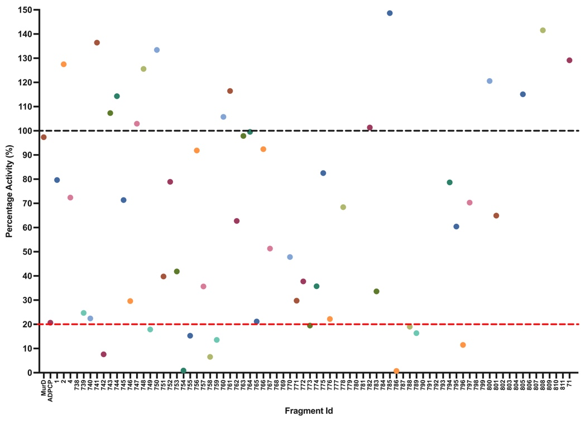

11 compounds displayed a percentage activity of 20% or less. These compounds were analysed for their effect on the assay components, Pi and the coupling enzyme, PNP, to confirm inhibiton.

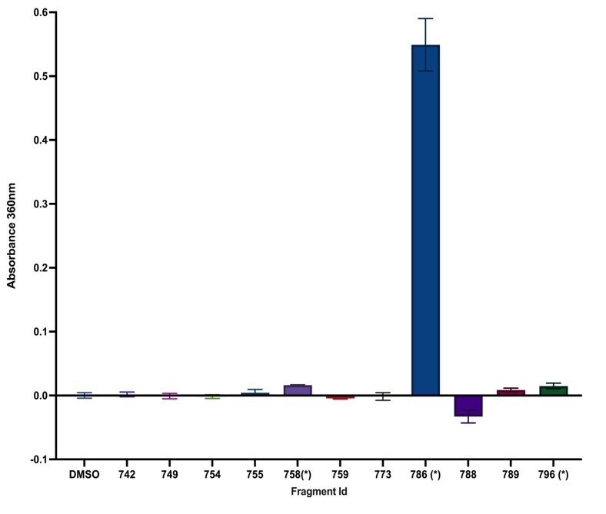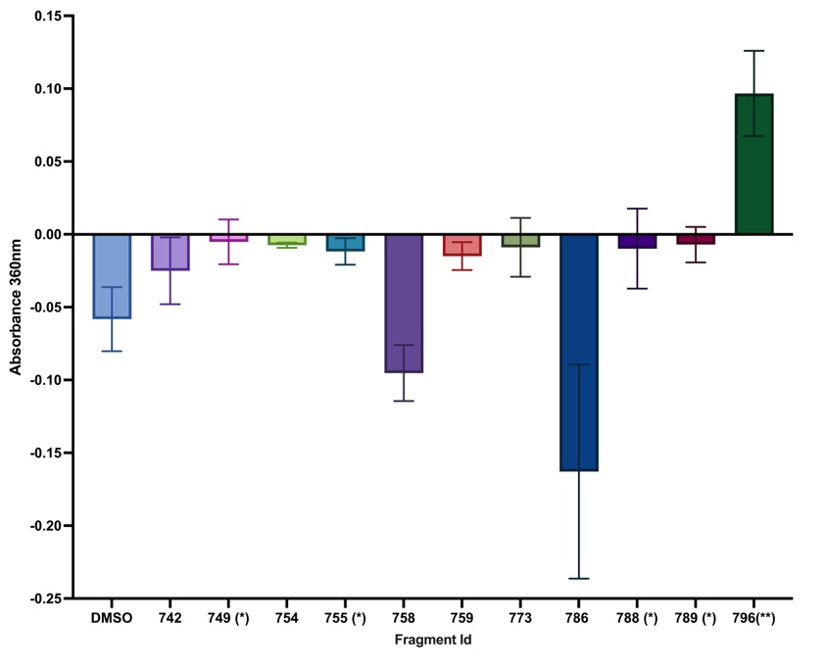

PNP

Pi

Assay components

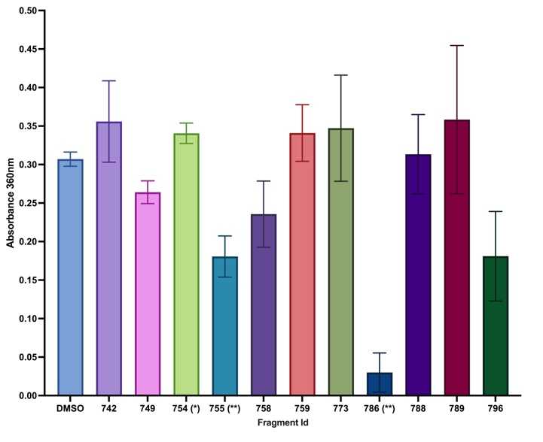

Fragments that caused a significant increase to the absorbance change at 360nm due to interference with the assay component or Pi, or caused a significant decrease to the absorbance change at 360nm due to interference with the coupling enzyme, PNP, were ruled out as inhibitors.

Dual Inhibitors against MurE

Compounds that did not have a significant effect on the coupling reaction were tested against MurE from *S. agalactiae* under the same assay conditions as MurD.

